**Start the Exam (UC-A1)**

• **Actor**: Student.

•**Brief description:** This use case describes how the student can start his exam.

•**Pre-conditions:**

There is an active network connection to local server.

sign in as student.

•**Post**-**condition**:

start displays exam time

display the first question.

**Flow of events:**

|  |  |
| --- | --- |
| **Actor** | **System** |
| 1. Click button “Start the Exam”. |  |
|  | 2.Request for new exam and get first question. |
|  | 3.Display the first question with his Expected answers. |
|  | 4.Show the total time of the exam and begins to decrease it. |
|  | 5. begins to decrease the specified time of Current question. |

**Critical scenario:**

1.Error with login information

2.Request to start the exam before the exam time so that the query algorithm is not yet started.

3.It is forbidden to apply for the exam.

**User Interface Prototype:**

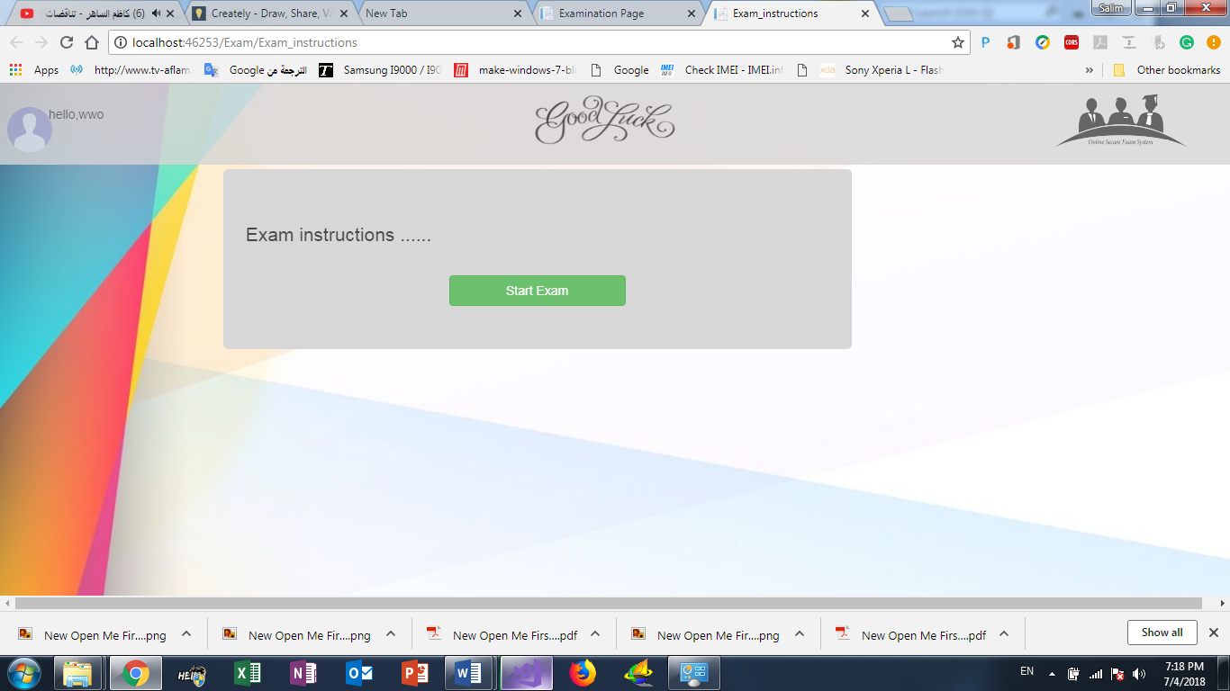

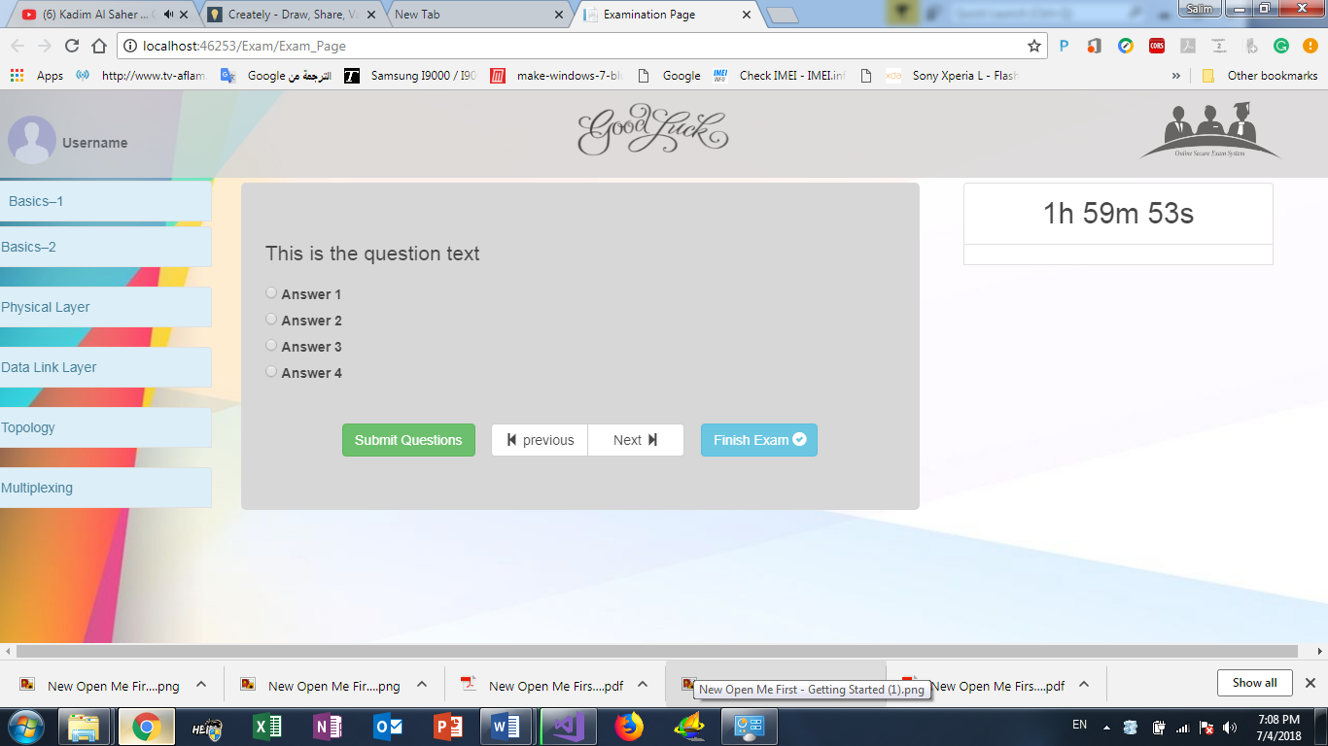

**Next Question (UC-A2)**

• **Actor**: Student.

• Brief **description**: This use case describes how the student submit his answer to get next question.

•**Pre-conditions:**

Signed in as student.

Started the exam.

Select his answer.

• **Post-condition:**

Correct the student's answer and display the next question.

**Flow of event:**

|  |  |
| --- | --- |
| Actor | System |
| 1. Click button “submit”. |  |
|  | 2.The system save student Answer |
|  | 3.Requset for next question. |
|  | 4.Display the question. |

**Critical scenario:**

Current question was the last one

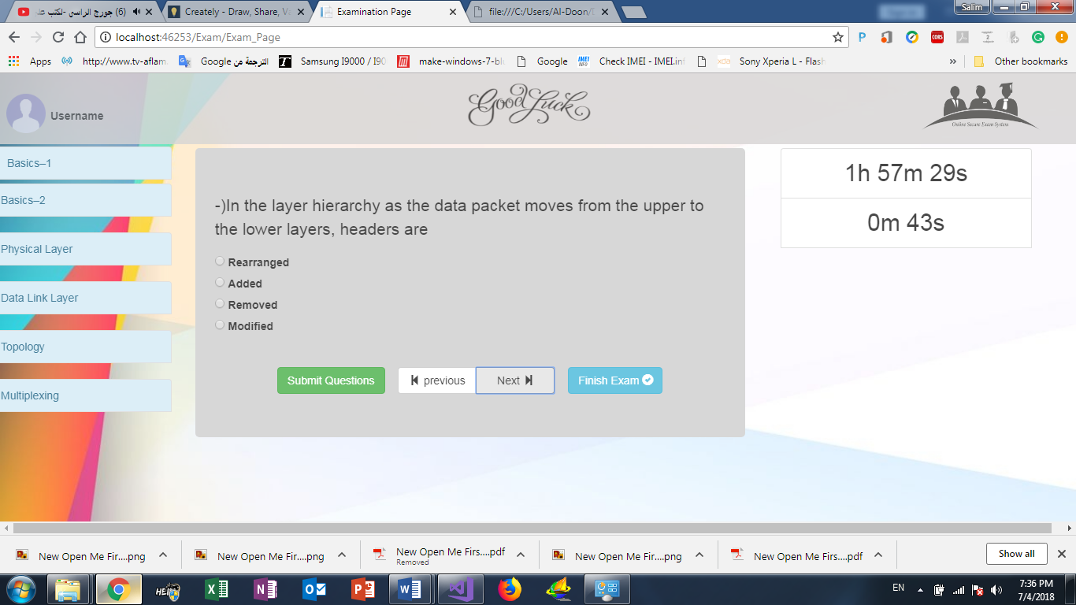**User interface prototype:**

Next Question

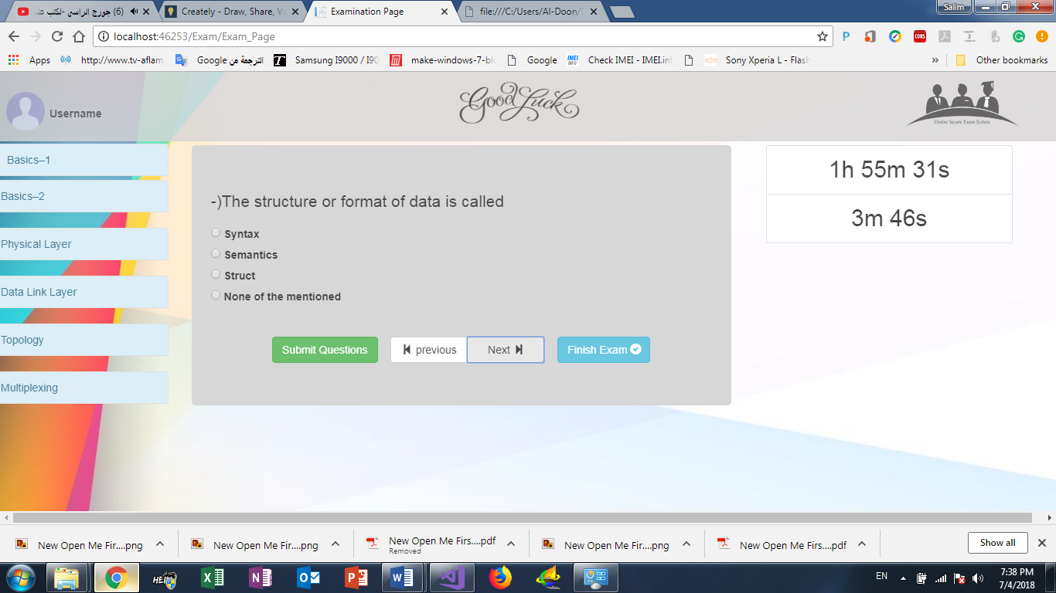

**Previous Question (UC-A3)**

• **Actor**: Student.

• Brief **description**: This use case describes how the student request for previous question.

•**Pre-conditions:**

Signed in as student.

Started the exam.

• **Post-condition:**

Get previous question with student answer’s if he answered the question

**Flow of event:**

|  |  |
| --- | --- |
| Actor | System |
| 1. Click button “previous”. |  |
|  | 2.The system save student Answer |
|  | 3.Requset for previous question. |
|  | 4.Display the question. |

**Critical scenario:**

Current question was the first one.

**Submit the answer (UC-A4)**

• **Actor**: Student.

• Brief **description**: This use case describes how the student submit question with his answer.

•**Pre-conditions:**

Signed in as student.

Started the exam.

Select his answer.

• **Post-condition:**

If student was sure his answer was correct ,he can submit the question then after submitted the question ,the question deletes from question list

**Flow of event:**

|  |  |
| --- | --- |
| Actor | System |
| 1. Click button “submit”. |  |
|  | 2.The system get student answer and request for Correct it. |
|  | 3.Requset for next question. |
|  | 4.Display the question. |

**Figure 22:Submit the answer flow of events**

**Critical scenario:**

No.

**Finish the exam (UC-A5)**

* **Actor**: Student.
* **Brief description**: This use case describes how the student can finish his exam and get his final result.
* **Pre-conditions**:

sign in as student.

Started the exam.

Answer a number of specific questions.

* **Post-condition**:

Show the student final result.

* **Flow of event**:

|  |  |
| --- | --- |
| Actor | System |
| 1. Click button “finish the Exam”. |  |
|  | 2.The system confirm the request from student before execution |
|  | 3.Requset for the final result of this student. |
|  | 4.Display the result with details. |

Figure 25: Finish the exam flow of events

**Critical scenario**:

**No**

**User Interface Prototype:**

